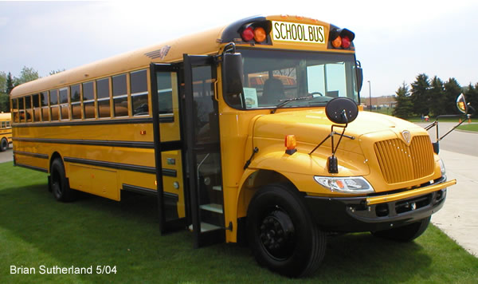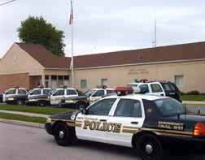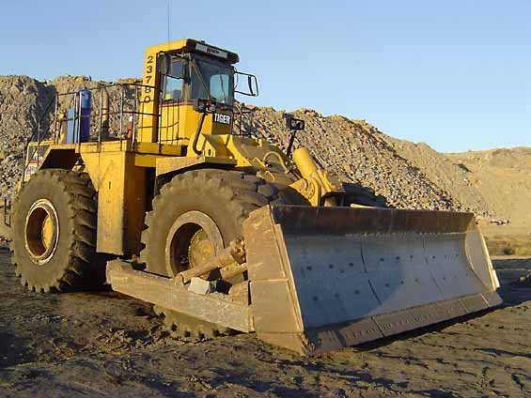
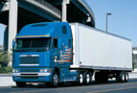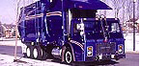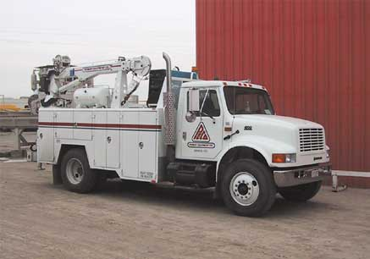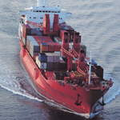

Entities Using or Testing Boron CLS Bond™
AUTOMOTIVE  Nissan  Ford  General Motors  Honda  Toyota  Hyundai  Daimler-Chrysler(NA)  Volvo N. America  RACING  NASCAR Racing Teams  Motorcycle Racing Teams  Boat Racing Teams  TRUCKING & AG.  Ryder Trucks  Sysco Systems Trucking  Swift Trucking  Detroit Diesel (Manufacturer)  Mack Trucks (Manufacturer)  Volvo Trucking  International  Caterpillar(Manufacturer)  John Deere Co.(Manufacturer)  Archer-Daniels-Midland  Western Trucking  GE Fleet Leasing | GOVERMENTAL/TRANSIT  United States Postal Service  Texas Dept. of Transportation  New York City Transit Authority  New York State Transportation  Hawaii Dept. of Transportation  Houston Metro. Transit Authority  New York City Waste Management  Mississippi Dept. of Transportation  Mississippi State Auditor’s Office  Chicago Transit Authority  Los Angeles County Sheriffs Dept.  Los Angeles Metro. Transit Authority  Union Pacific Railroad  Canadian National Railway  General Electric (US) Diesel Division)  Shandong Province, China  INDUSTRIAL  Johns Manville  Ferris Induatries  General Electric Turbines  General Electric Propulsion  GE Wind Energy  Halliburton Corporation  Phelps-Dodge Mining  Honeywell  Nihon Chemical  Arizona Pipeline  Mitsubishi Heavy Industries  Mitsubishi Metals  Mabuchi Motors  Hitachi Refrigeration | AVIATION  Boeing  Kaiman Aerospace  Rotax  Snecma  CONSUMER  Hewlett-Packard  SONY  Panasonic  Samsung  MARINE  Northrop Grumman  Raceway Marine  Southern Marine  Hyundai  Samsung  Volvo Penta  MILITARY  United States Army  Northrop Grumman  Swedish Army  Lockheed Martin  UTILITIES  Florida P & L  TVA  Entergy
ALS
Advanced Lubrication Solutions

